Redmi Note 12 Pro 5G

LKR 89,999



### Redmi Note 12

#### LKR 59,999



### Redmi 12C

#### LKR 34,999



### Apple 20W adapter

#### LKR 8,990

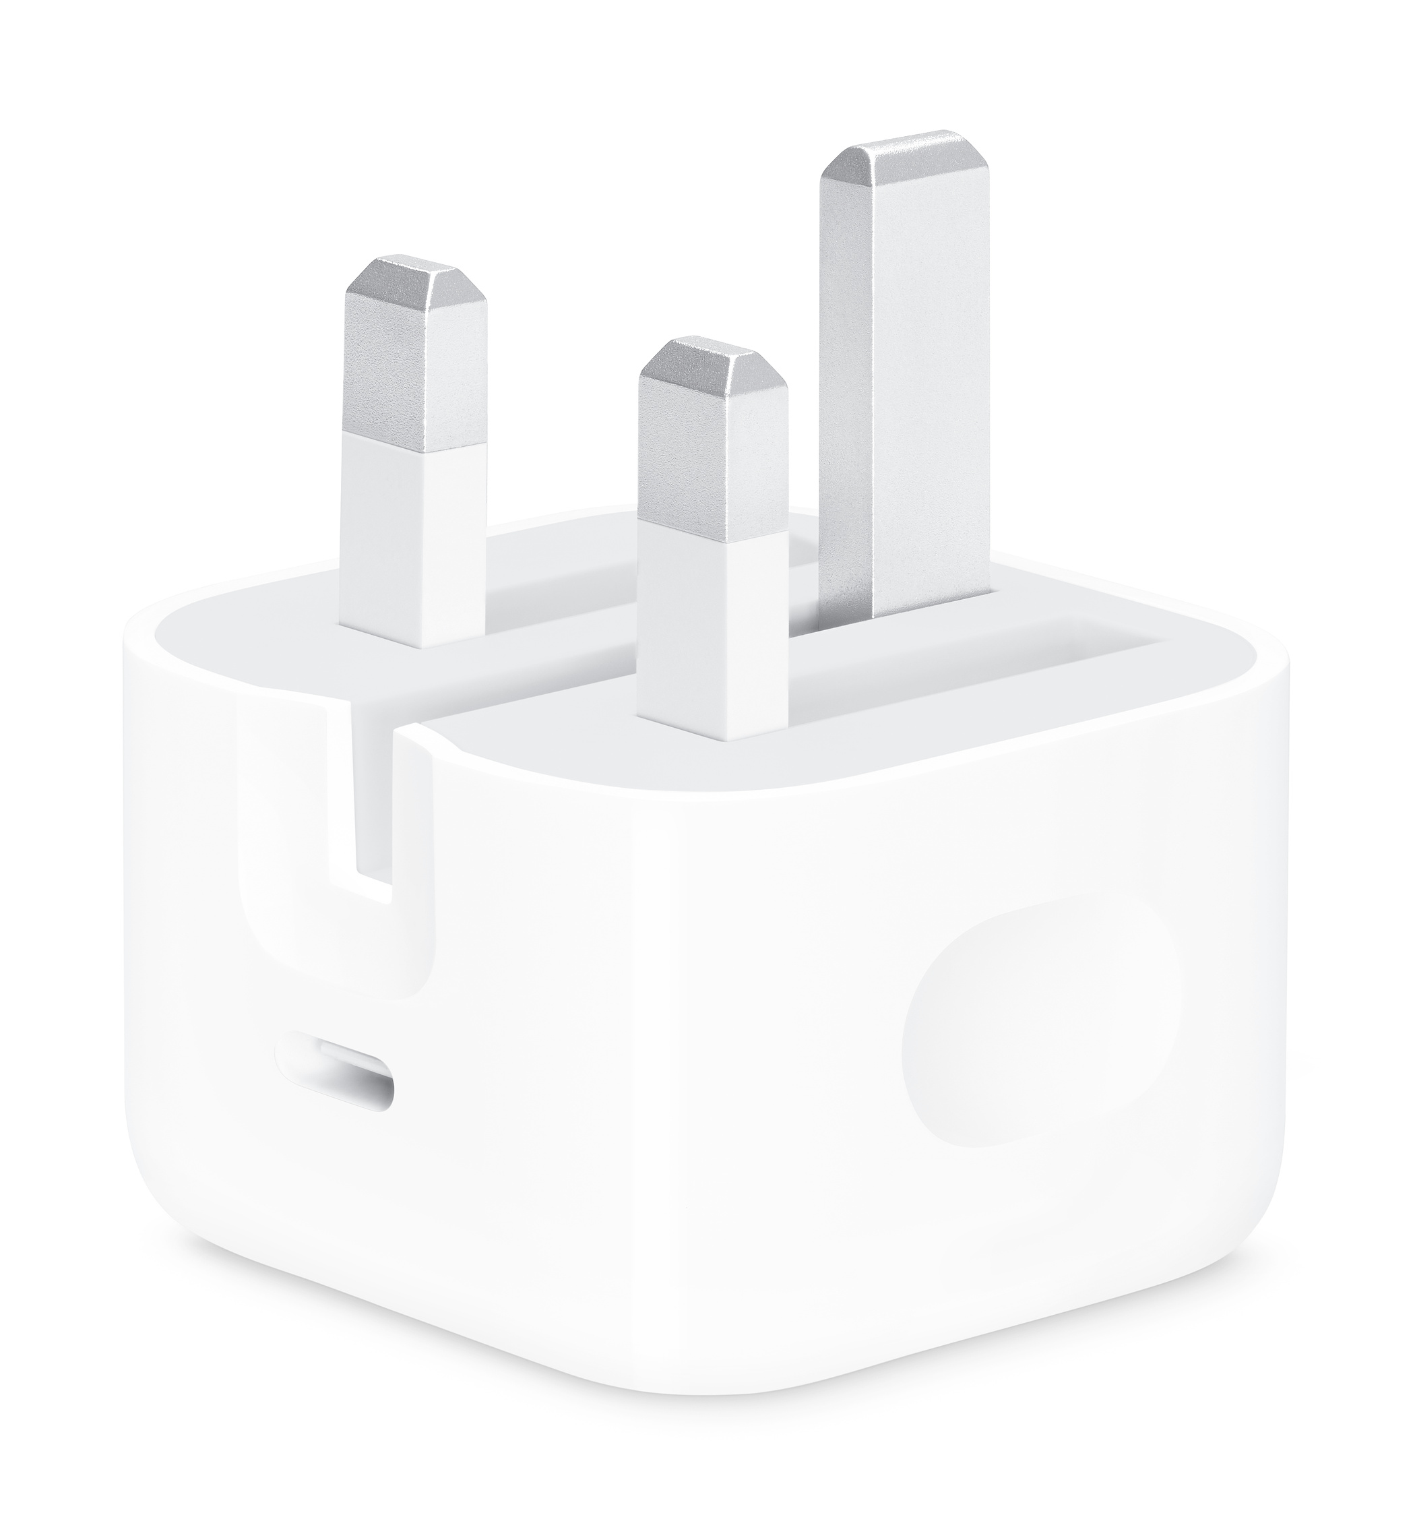

### Aspor A323 10000 MAh Power Bank

#### LKR 4,999

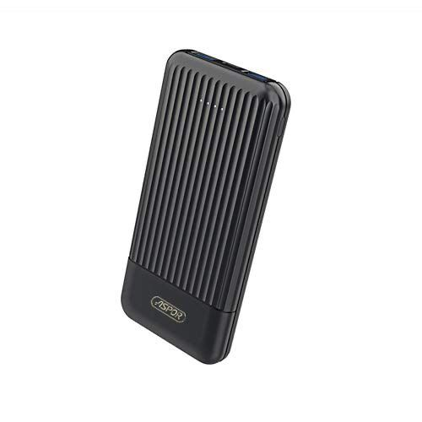

### REDMI SONICBASS WIRELESS EARPHONES

#### LKR 6,999

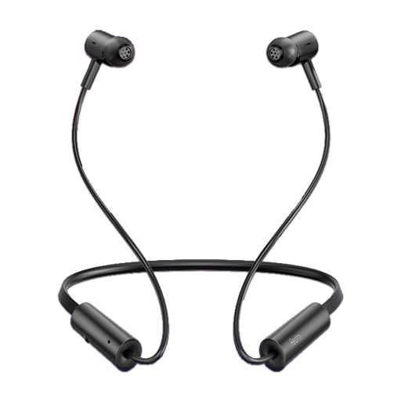

### Mi Selfie Stick Tripod

25000

